Applicant-Determined Performance Measure Supplement and Suggested Applicant Determined Performance Measures for
Native Nations

AmeriCorps State and National
2026

Contents
What is an Applicant-Determined Performance Measure? 3
Applicant-Determined Performance Measure Rules 3
Entering Information into eGrants 3
Suggested Applicant Determined Performance Measures for Native Nations 14

Purpose
As stated in the Performance Measure Instructions, applicants are required to create at least one aligned performance measure (an output paired with an outcome) connected to their primary intervention. Applicants are required to use National Performance Measures if they fit their program’s Theory of Change. Programs that do not fit within the National Performance Measures may create an applicant-determined measure. This supplement provides more information on when and how to create applicant-determined performance measures in AmeriCorps’ web-based grants management system, eGrants.

Applicants should only create applicant-determined measures after reviewing the Application Instructions and the Performance Measure Instructions to ensure understanding of the performance measure requirements and selection rules.

What is an Applicant-Determined Performance Measure?
An applicant-determined performance measure is one in which the applicant creates the language for the outputs and/or outcomes that will be measured. This is different from the National Performance Measures, where AmeriCorps pre-determines common outputs and outcomes that are available for applicants to use.

Applicant-Determined Performance Measure Rules
Applicant-determined performance measures must follow all of the requirements listed in the Performance Measure Instructions. The following elements also apply specifically to applicant-determined performance measures.

Applicant-determined performance measures can be:
- An output and outcome pairing
- An outcome paired with a National Performance Measure output

Applicant-determined performance measures cannot:
- Be an output paired with a National Performance Measure outcome
- Duplicate already established National Performance Measures

There are some objectives for which the creation of applicant-determined outputs is not allowed:
- Capacity Building and Leverage (in the Capacity Building focus area)
- Find Opportunity (in the Economic Opportunity focus area)
- Teacher Corps (in the Education focus area)
- Access & Attract (in the Veterans and Military Families focus area)

Entering Information into eGrants
Click on Performance Measure on the left hand navigation to take you to the home screen of the Performance Measures Module. Click on the link to enter Performance Measures.

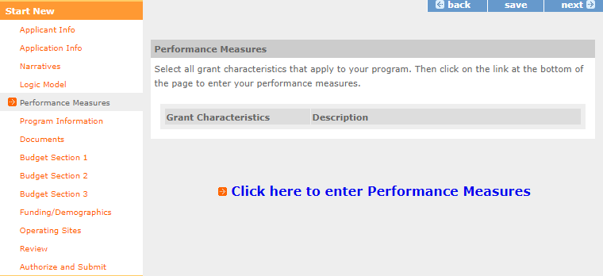
Figure 1: The link to begin the Performance Measures Module in eGrants.
Click Begin.

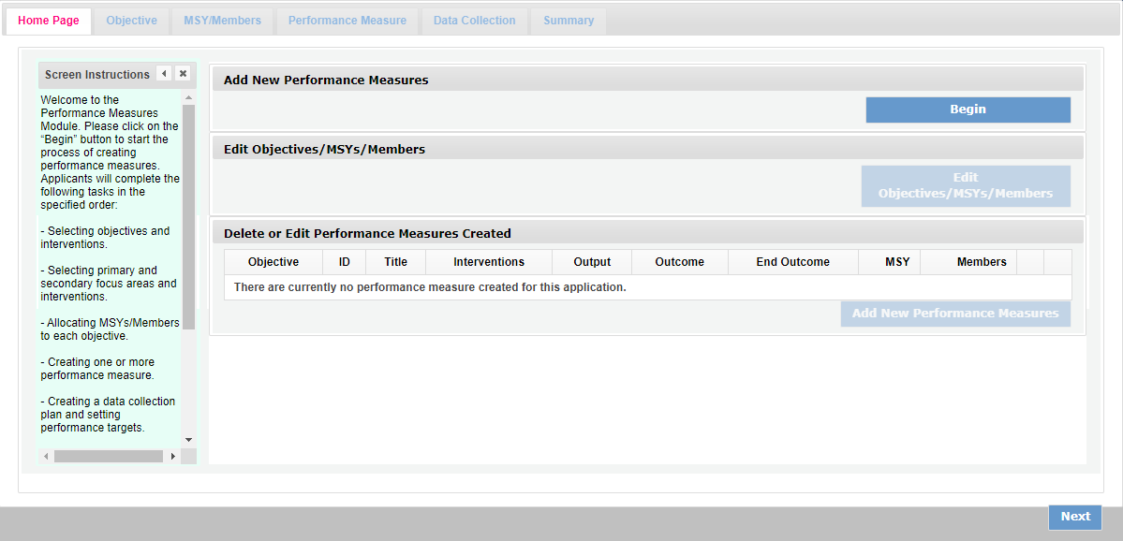
Figure 2: The Home Page tab of the Performance Measures Module featuring the Begin button.
On the Objective tab, find the focus area(s) that applies to the program. If none apply, then select Other Community Priorities. Under the focus area, select the objective(s) of the program activity. If none of the objectives in the focus area apply, select “Other [Focus Area]” if available.

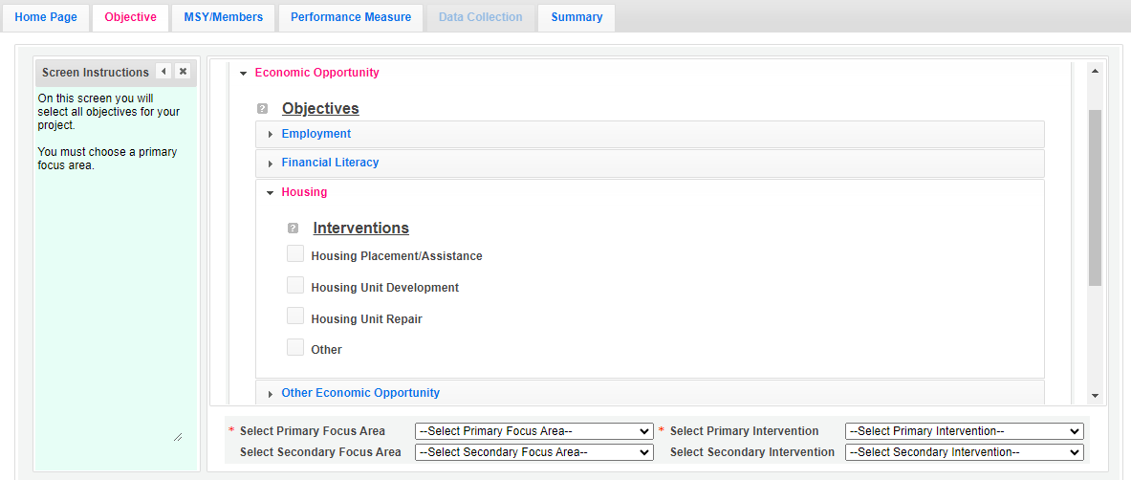
Figure 3: The Objective tab of the Performance Measures Module with the Economic Opportunity focus area and Housing objective field expanded.
Check the box of the intervention(s) that are part of the program design. If none of the interventions apply, check the box next to “Other.”

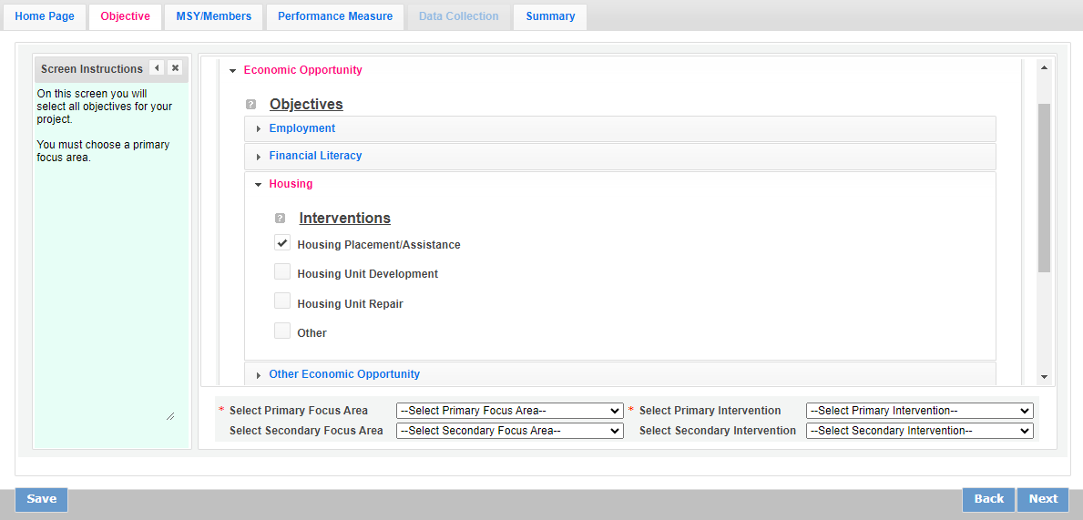
Figure 4: The Objective tab with the Housing Placement/Assistance intervention checked.
Select the Primary Focus Area and Primary Intervention. Options in the dropdown populate based on the selections made on this tab. If applicable, select the Secondary Focus Area and Secondary Intervention. Applicants are not required to select a Secondary Focus Area or Secondary Intervention. Click Next.

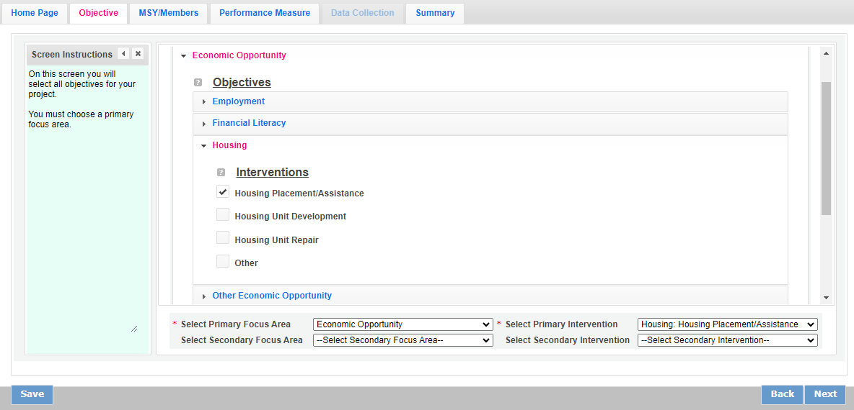
Figure 5: The Objective tab with the primary focus area and primary intervention selected.
On the MSY/Members tab, enter the number of total MSY for the project, as well as the number of MSY and members for each objective. Click Next.

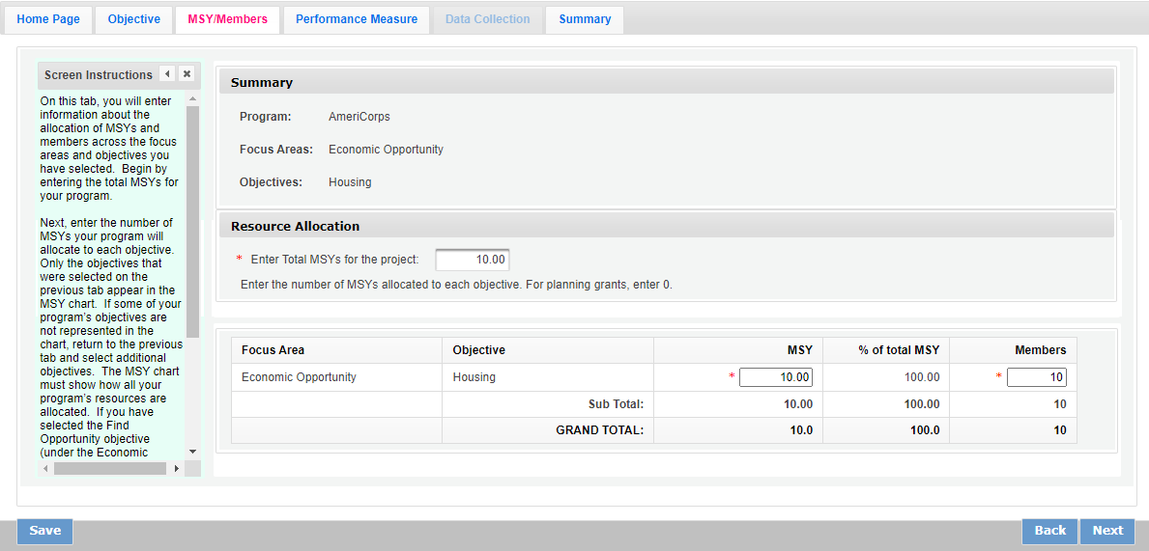
Figure 6: The MSY/Member tab of the Performance Measures Module showing the total MSY for the project, MSY allocated to the objective, and Members allocated to the objective.
On the Performance Measure tab, select the objective for the performance measure. Options in the dropdown populate based on information entered on the Objective tab. Enter the title of the performance measure and the problem statement. Check the box of the intervention for this performance measure. The options are based on information entered on the Objective tab. If you selected “Other” on the Objective tab, check the box next to the empty field and enter the name of your intervention. Please note: do not add an applicant-determined intervention that duplicates an intervention already available in the system.

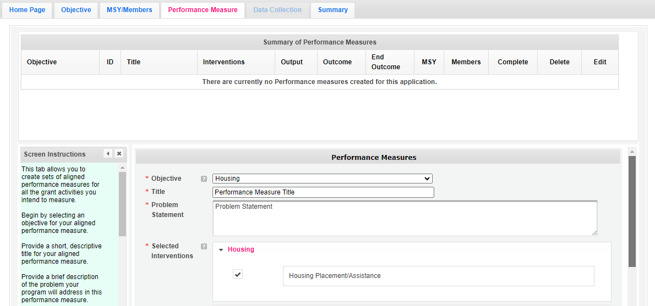
Figure 7: The Performance Measures tab of the Performance Measures Module with objective, title, problem statement, and intervention entered.
In the Outputs section, select which output to measure. Options in the Outputs section are based on the selected Objective. Only pick one output per performance measure.

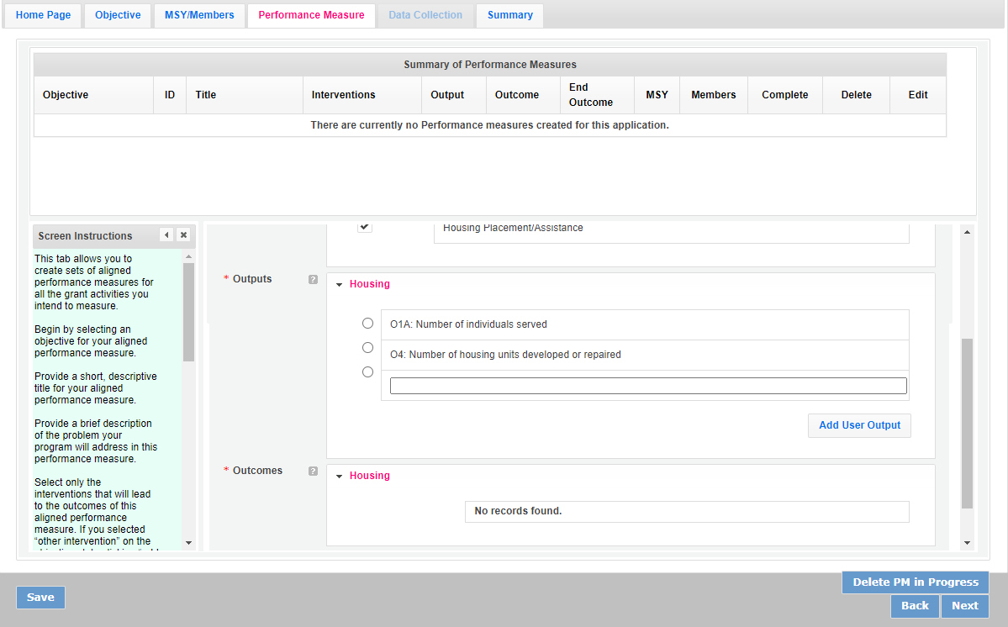
Figure 8: The Performance Measures tab showing the available Outputs associated with the selected objective.
If you select a National Performance Measure output, the Outcomes section will populate with either the options for a National Performance Measure outcome that aligns with the selected National Performance Measure output or a space for an applicant-determined outcome. It is allowable to have a National Performance Measure output paired with an applicant-determined outcome.

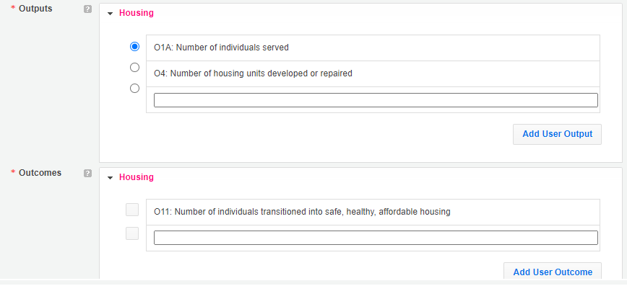
Figure 9: The Performance Measures tab showing the available Outcomes associated with the selected National Performance Measure output.
To create the applicant-determined outcome, check the box next to the empty field, then enter the name of the outcome.

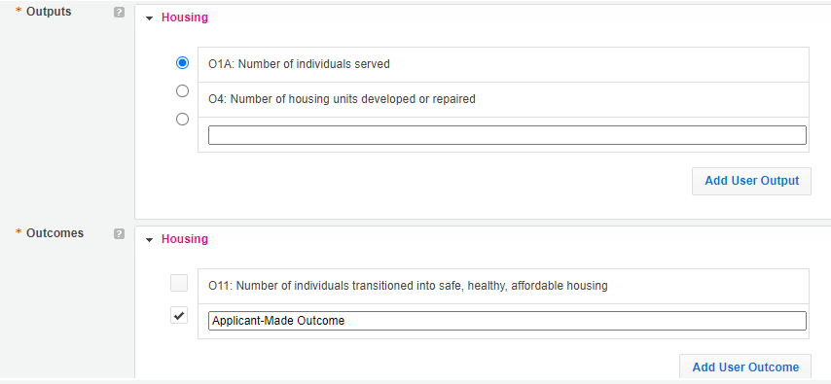
Figure 10: The Performance Measures tab showing an example of a National Performance Measure output paired with an applicant-determined outcome.
If you create an applicant-determined output, only an applicant-determined outcome will be available. It is allowable to have an applicant-determined output paired with an applicant-determined outcome. It is not allowable to have an applicant-determined output paired with a National Performance Measure outcome.

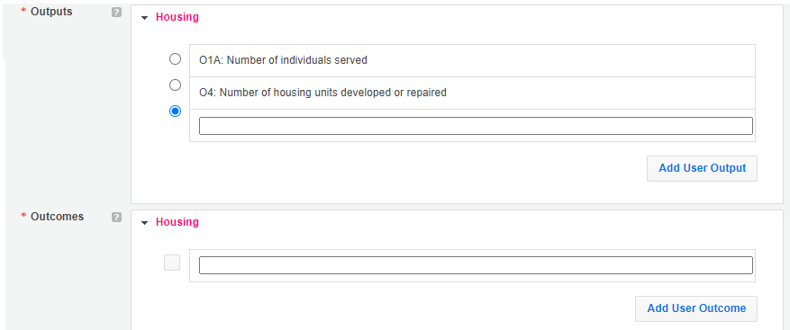
Figure 11: The Performance Measures tab showing that only applicant-determined outcomes are available if creating an applicant-determined output.

To create an applicant-determined output, click the radial next to the empty field, then enter the name of the output. To create an applicant-determined outcome, check the box next to the empty field, then enter the name of the outcome. Remember: do not duplicate any National Performance Measures in the applicant-determined measure fields.

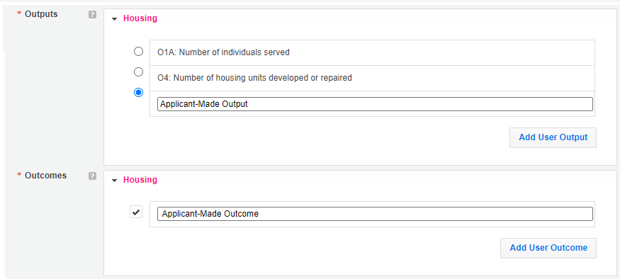
Figure 12: The Performance Measures tab showing an example of an applicant-determined output paired with an applicant-determined outcome.
Enter the number of MSY and Members associated with this Performance Measure. Click Next.

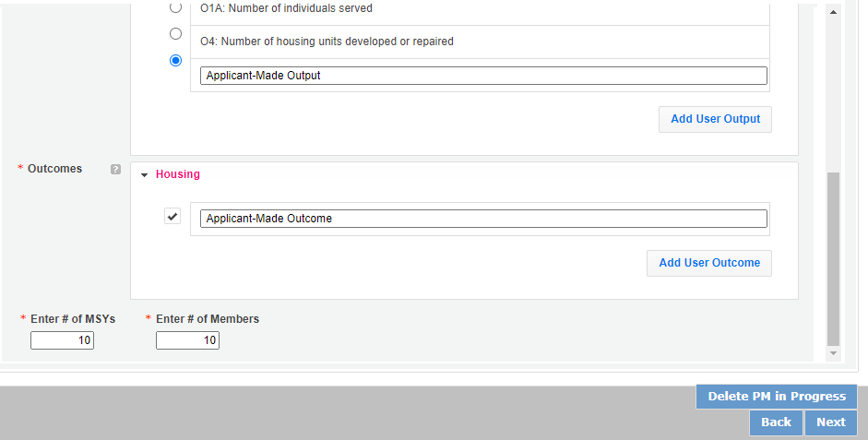
Figure 13: The Performance Measures tab showing the MSY and Members associated with the performance measure.
On the Data Collection tab, enter the description of the intervention. Click on the arrow to expand the data collection section. For applicant-determined measures, the only method available is “Other.” Enter the instrument description and target number of outputs and the unit of the outputs.

Applicant-determined measures do not have system-set units of measure so the applicant will need to enter the appropriate unit. The unit of measure should describe the beneficiary population you intend to count.

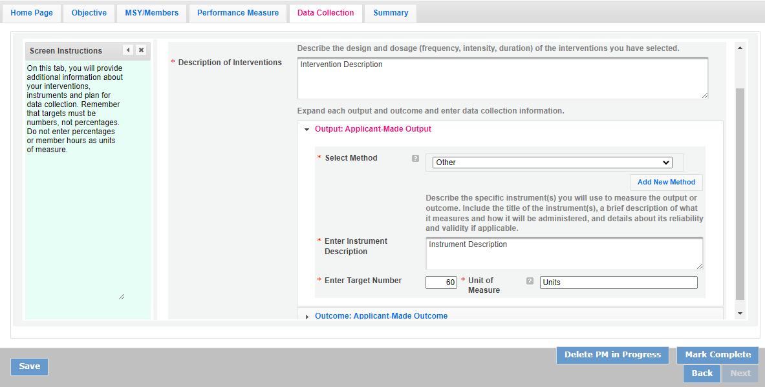
Figure 14: The Data Collection tab of the Performance Measures Module with the method selected and the unit of measure entered for an applicant-determined output.
For National Performance Measures, there are options for methods to measure the output based on the definitions in the Performance Measure Instructions. The unit of measure is also system-set so that it aligns with the National Performance Measure selected; it cannot be edited.

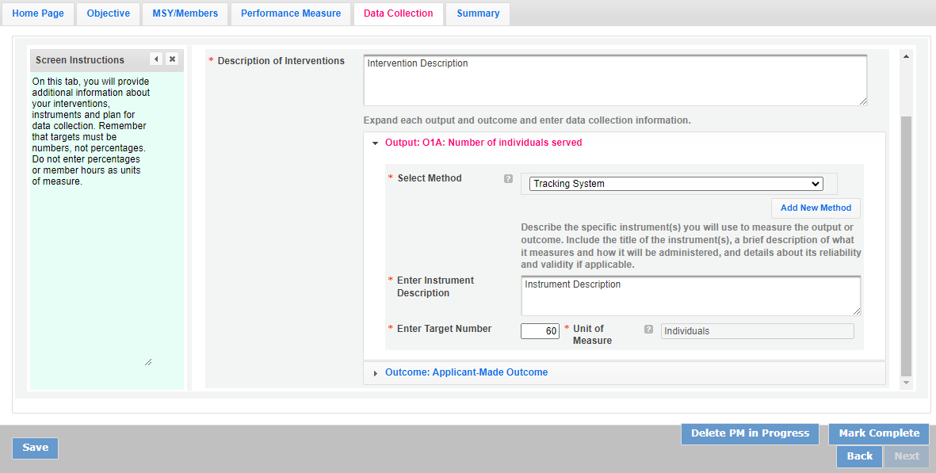
Figure 15: The Data Collection tab containing other options for the method and the system-set unit of measure for a National Performance Measure.
Enter the data collection method for the applicant-made outcome as well. Similar to the applicant-made output, the only method is “Other,” and the applicant must state the unit of measure. In most cases, the unit of measure should be the same for the output and outcome(s) in an aligned performance measure. Once the measure is finished, click Mark Complete.

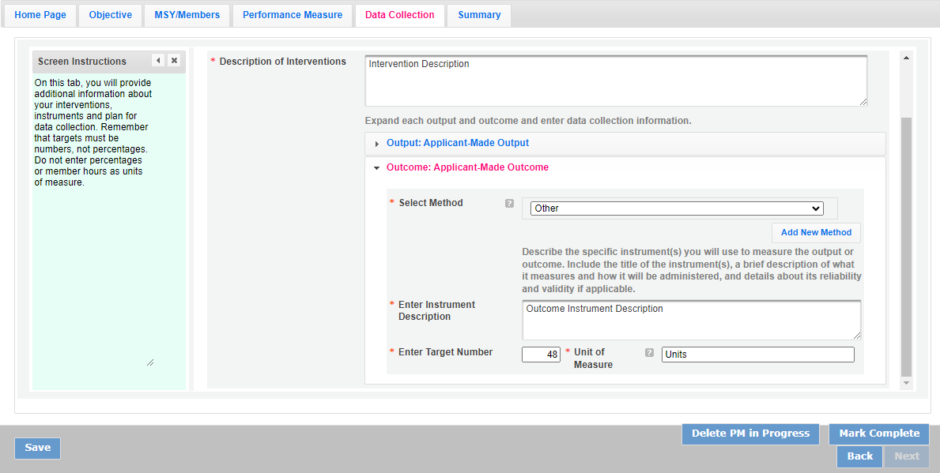
Figure 16: The Data Collection tab with the method selected and the unit of measure entered for an applicant-determined outcome.
The system will return the applicant to the Performance Measure tab. All created performance measures are noted at the top of the Performance Measure tab. All applicant-determined outputs begin with OUTPT and all applicant-determined outcomes begin with OUTCM.

If you would like to create another performance measure, repeat the process. Applicants are required to create at least one aligned performance measure (an output paired with an outcome) connected to their primary intervention. Applicants are not expected to have performance measures for every program activity.

When the applicant has finished designing the performance measures, click Next at the bottom of the page.

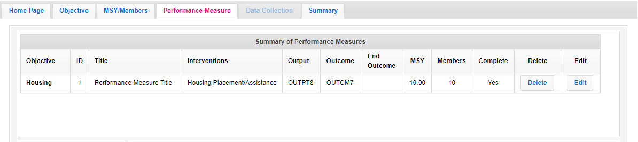
Figure 17: The Performance Measure tab lists the completed applicant-determined performance measure.
The Summary tab provides a summary of the data entered in the Performance Measure Module. When ready, click Validate Performance Measures.

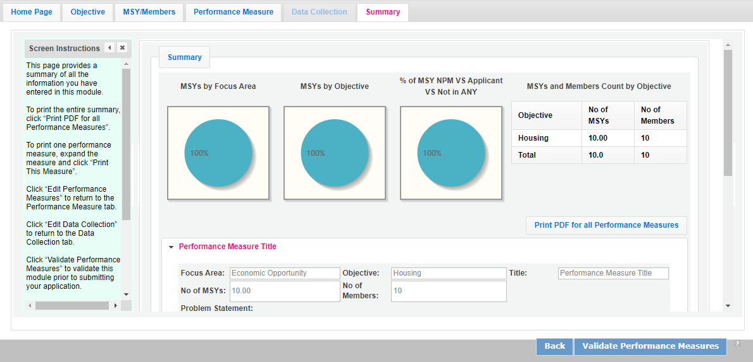
Figure 18: The Summary tab of the Performance Measure Module showing the summary of the applicant-determined performance measure and the Validate Performance Measures button.
If there are no errors with the Performance Measure Module, a notification will appear stating “Success: All Performance Measures are valid.”

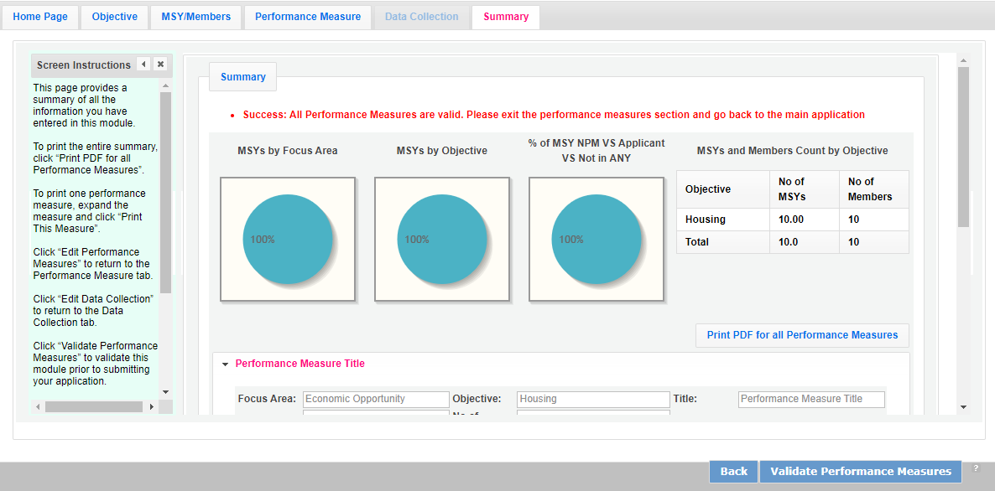
Figure 19: The Summary tab stating the performance measure is valid.

Suggested Applicant Determined Performance Measures for Native Nations
Disaster Services

Strategic Plan Objective | Selection Rules |  | Interventions
Strategic Plan Objective | Outputs | Outcomes (if applicable)* | Interventions
Assistance Provided | D1A: Number of individuals served | D5: Number of individuals reporting increased disaster readiness | Traditional Ecological Knowledge (TEK) .  Disaster Preparation  Disaster Response  Disaster Recovery  Disaster Mitigation  Disaster Adaptation  Climate Change Intervention
Assistance Provided | D6: Number of structures protected or restored | D7: Number of structures returned to regular use after a disaster | Traditional Ecological Knowledge (TEK)  Disaster Preparation  Disaster Response  Disaster Recovery  Disaster Mitigation  Disaster Adaptation  Climate Change Intervention
Assistance Provided | Acres of Tribal land or protected land treated | Acres of Tribal land or protected land improved | Traditional Ecological Knowledge (TEK)  Disaster Preparation  Disaster Response  Disaster Recovery  Disaster Mitigation  Disaster Adaptation  Climate Change Intervention
Assistance Provided | Miles of Tribal land or protected land treated. | Miles of Tribal land or protected land improved | Traditional Ecological Knowledge (TEK)  Disaster Preparation  Disaster Response  Disaster Recovery  Disaster Mitigation  Disaster Adaptation  Climate Change Intervention
Assistance Provided | G3-3.4**: Number of organizations that received capacity building services | G3-3.10A**: Number of organizations that increase their efficiency, effectiveness, and/or program reach | Traditional Ecological Knowledge (TEK) Disaster Preparation  Disaster Response  Disaster Recovery  Disaster Mitigation  Disaster Adaptation  Climate Change Intervention
*All National Performance Measure outputs may also be paired with an applicant-determined outcome instead or may be used without an associated outcome.

**In the eGrants Performance Measure Module, these measures may appear with the letter “D” at the end when used in the Disaster Services focus area. However, the instructions for these measures are the same regardless of the focus area in which they are used.

Education

Strategic Plan Objective | Selection Rules |  | Interventions
Strategic Plan Objective | Outputs | Outcomes (if applicable)* | Interventions
School Readiness | ED1A: Number of individuals served | Number of individuals with increased knowledge of Native American/Indigenous language and culture | Tutoring  Mentoring  Other Classroom Support  Out-of-School Time  Family Involvement  Service Learning  Summer Learning  Classroom Teaching
K-12 Success | ED1A: Number of individuals served | Number of individuals with increased knowledge of Native American/Indigenous language and culture  ED5A: Number of students with improved academic performance  ED9: Number of students graduating from high school on time  ED10: Number of students enrolling in post-secondary education/training  ED27C: Number of students with improved academic engagement or social-emotional skills  ED6: Number of students with increased attendance  ED7A: Number of students with decreased disciplinary incidents (referrals, suspensions/expulsions, criminal or gang involvement) | Tutoring  Mentoring  Coaching  Other Classroom Support  Out-of-School Time  Family Involvement  Service Learning  Summer Learning  Classroom Teaching  Opioid/Drug Intervention
Post-HS Education Support | ED1A: Number of individuals served | Number of individuals with increased knowledge of Native American/Indigenous language and culture  ED11: Number of individuals earning a post-secondary degree or technical certification | Tutoring  Mentoring  Family Involvement  Service Learning  Summer Learning
Teacher Corps | N/A (outputs may be reported as Performance Data Elements on annual Progress Reports) | N/A (outcomes may be reported as Performance Data Elements on annual Progress Reports) | N/A
Other Education | ED1A: Number of individuals served | Applicant-determined | Applicant-determined
*All National Performance Measure outputs may also be paired with an applicant-determined outcome instead or may be used without an associated outcome.

Focus Area Notes
- Programs should only opt into the Education performance measures if the measures reflect significant program activities aligned with the applicant’s core theory of change.
- All individuals counted under these measures must be program beneficiaries, not National Service Participants. National Service Participant outputs and outcomes should be reported in the Performance Data Elements in annual Progress Reports.
Activities associated with these measures must be carried out by National Service Participants or by volunteers directly recruited and/or supported by National Service Participants.
ED27C (outcome) | Number of students with improved academic engagement or social and emotional skills
Definition of  Key Terms | Students: those reported in ED1A  Improved academic engagement or social and emotional skills: A positive change in student skills, attitude, and/or mindset that is likely to contribute to increased educational success. May include increased interest in school, improved perspective on school climate, increased attachment to school and/or increased educational aspirations.  Social-emotional skills developed through more specific routes of Native Culture and Language include but are not limited to healing; improved emotional/mental health; resilience; improved self/communal-identity; increased connection/relationship to community, land, and culture.
How to Measure/  Collect Data | Survey, observation, or other instrument capable of measuring changes in academic engagement or social and emotional skills at the individual beneficiary level. When possible, pre-post assessments should be utilized.
Notes | Academic or behavioral improvements counted under ED5A, ED6, or ED7A cannot be counted under this measure

Environmental Stewardship

Strategic Plan Objective | Selection Rules |  | Interventions
Strategic Plan Objective | Outputs | Outcomes (if applicable)* | Interventions
At-Risk Ecosystems | Acres of Tribal or protected lands treated | Acres of Tribal or protected lands improved | Fire Mitigation  Flood Mitigation  Invasive Species Removal  Debris Removal  Plant Establishment  Climate Change Intervention  Traditional Ecological Knowledge (TEK)
At-Risk Ecosystems | Miles of Tribal or protected lands treated. | Miles of Tribal or protected lands improved | Trail Creation  Trail Remediation  Stream Remediation  Fire Mitigation  Flood Mitigation  Invasive Species Removal  Debris Removal  Plant Establishment  Climate Change Intervention  Traditional Ecological Knowledge (TEK)
Energy Efficiency | EN1: Number of housing units or public structures weatherized or retrofitted to improve energy efficiency | EN1.1: Number of housing units or public structures with reduced energy consumption or reduced energy costs | Weatherization  Retrofitting  Climate Change Intervention  Traditional Ecological Knowledge (TEK)
Awareness & Stewardship | EN3: Number of individuals receiving education or training in environmental stewardship and/or environmentally-conscious practices | EN3.1: Number of individuals with increased knowledge of environmental stewardship and/or environmentally-conscious practices  EN3.2: Number of individuals reporting a change in behavior or intention to change behavior to better protect the environment | Education/Training  Service Learning  Climate Change Intervention  Traditional Ecological Knowledge (TEK)
Green Jobs | N/A (outputs may be reported as Performance Data Elements on annual Progress Reports) | N/A (outcomes may be reported as Performance Data Elements on annual Progress Reports) | N/A
*All National Performance Measure outputs may also be paired with an applicant-determined outcome instead or may be used without an associated outcome.

Healthy Futures

Strategic Plan Objective | Selection Rules |  | Interventions
Strategic Plan Objective | Outputs | Outcomes (if applicable)* | Interventions
Aging in Place | H4A: Number of individuals served | Number of Individuals who report increased access to healthy foods (tribal or rural communities)  H9A: Number of individuals who report improved capacity for independent living  H19: Number of individuals with improved health | Food Sovereignty  Companionship  Nutrition/Food Support  Legal Services  Transportation  Medical Services  Opioid/Drug Intervention
Obesity & Food | H4A: Number of individuals served | Number of Individuals who report increased access to healthy foods (tribal or rural communities)  H12: Number of individuals who report increased food security  H17: Number of individuals with increased health knowledge  H18: Number of individuals reporting a change in behavior or intent to change behavior to improve their health  H19: Number of individuals with improved health | Food Sovereignty  Outreach  Education/Training  Referrals  Medical Services  Nutrition/Food Support  Physical Activities  Counseling/Coaching  Opioid/Drug Intervention
Obesity & Food | H10A: Number of pounds of food provided | Applicant-determined | Food Sovereignty  Nutrition/Food Support
Access to Care | H4A: Number of individuals served | H17: Number of individuals with increased health knowledge  H18: Number of individuals reporting a change in behavior or intent to change behavior to improve their health  H19: Number of individuals with improved health  H20: Number of individuals with improved access to medical care | Outreach  Education/Training  Referrals  Medical Services  Counseling/Coaching  Opioid/Drug Intervention
Other Healthy Futures | H4A: Number of individuals served | Applicant-determined | Applicant-determined
*All National Performance Measure outputs may also be paired with an applicant-determined outcome instead or may be used without an associated outcome.

Veterans and Military Families

Strategic Plan Objective | Selection Rules |  | Interventions
Strategic Plan Objective | Outputs | Outcomes (if applicable)* | Interventions
Veterans & Families Served | V1: Number of veterans served  V7A: Number of active military members and/or military family members served  V8: Number of veteran family members served | Number of individuals with increased knowledge of cultural well-being and/or addressing stigma of mental health services  O9**: Number of individuals with improved financial knowledge  O11**: Number of individuals transitioned into safe/affordable housing  O10**: Number of individuals who secure employment  O21**: Number of individuals with improved job readiness  ED11**: Number of individuals earning a post-secondary degree or technical certification  H9A**: Number of individuals who report improved capacity for independent living  H12**: Number of individuals who report increased food security  H17**: Number of individuals with increased health knowledge  H18**: Number of individuals reporting a change in behavior or intent to change behavior to improve their health  H19**: Number of individuals with improved health  H20**: Number of individuals with improved access to medical care | Native Culture and Language Support  Financial Literacy Education  Housing Unit Development  Housing Unit Repair  Housing Placement/Assistance  Job Training  Job Placement  GED Education  Other Adult Education  Tutoring  Mentoring  Family Involvement  Service Learning  Summer Learning  Companionship  Nutrition/Food Support  Legal Services  Transportation  Outreach  Referrals  Medical Services  Physical Activities  Counseling/Coaching  Opioid/Drug Intervention
Access & Attract | N/A (outputs may be reported as Performance Data Elements on annual Progress Reports) | N/A (outcomes may be reported as Performance Data Elements on annual Progress Reports) | N/A
*All National Performance Measure outputs may also be paired with an applicant-determined outcome instead or may be used without an associated outcome.

**In the eGrants Performance Measure Module, these measures may appear with the letter “V” at the end when used in the Veterans and Military Families focus area. However, the instructions for these measures are the same regardless of the focus area in which they are used.

